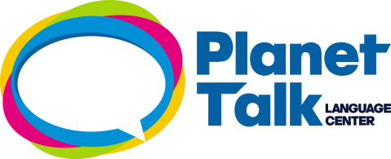

IMAGINE DRAGONS – I BET MY LIFE

Idina Menzel
/

I know I 1.______________ the path that you would 2._____________ want for me
I 3._____________ I let you down, 4._____________
So many 5._____________ nights
Where you were 6._____________ up on me
Well I'm just a 7._____________ unto the night

Now 8._____________ when I told you that's the last you'll 9._____________ of me
Remember when I 10.____________________________________
I know I 1.______________ the path that you would 2._____________ want for me
I 11._____________ you hell through all the 12_____________
[Chorus]
So I, I bet my life, I bet my life
I bet my life 13,_____________
I, I bet my life, I bet my life
I bet my life 14._____________
I've been 15._____________ the world but never in my 16._____________ dreams
Would I come 17. _______________ 18.___________ to you
I've told a 19._____________ 20._____________
But now I tell a 21.____________________
There's you in 22._____________ I do
BRIDGE + CHORUS
Don't tell me that I'm 23._____________
I've walked that road 24._____________
I left you on your 25._____________
And please 26._____________ them when they say
That it's left for 27._____________
And the records that I've 28._____________
Please 29._______________________________________
CHORUS 2X

ANSWERS:
1. SEA
2. DAY
3. ONE
4. LONELINESS
5. MAN
6. BEAR (EMOTICON “HINT” USING THE NOUN NOT THE VERB)
7. RESCUE
8.BEFORE
9. DESPAIR
10. S.0.S
11. WORLD
12. HOPE
13. SOMEONE
14. YEAR
15. WROTE
16. SHOULD HAVE
17. RIGHT FROM THE START
18. KEEP
19. TOGETHER
20. MEND
21. LIFE
22. BREAK
23. HEART

UNSCRAMBLE SEQUENCE: 2 -1 – 3 -4 -7 -6 -5

YOUTUBE LINK: https://www.youtube.com/watch?v=Nbqtlqk4LFU

